RESEARCH INFOTECH

DAILY ANALYSIS
17-01-2018

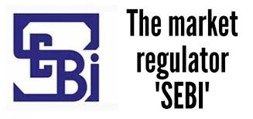
TV18BRDCST (TV18BRDCST)
(NSECash)

S1 | S2 | PP | R1 | R2
55 | 58 | 60 | 62.50 | 65

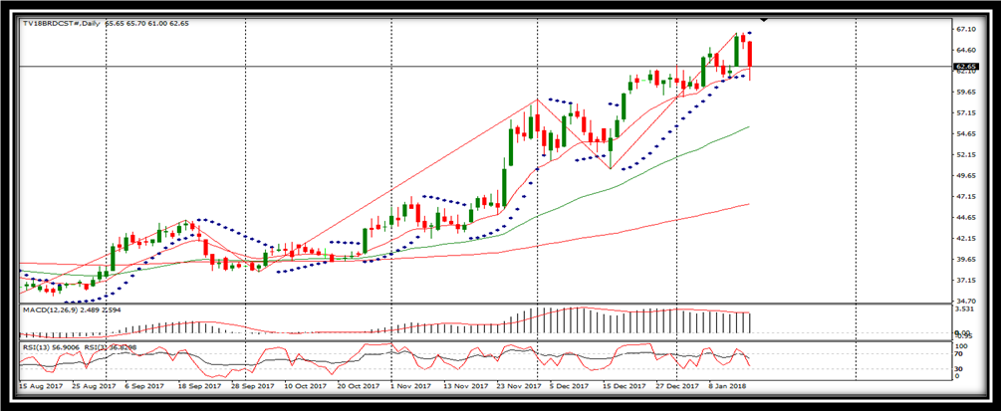
BUY | 59.50-60 | SL-56
TGT 1- 65 | TGT 2- 75 | SL-56
DESCRIPTION
TV18 Broadcast Limited, formerly ibn18 Broadcast Limited, is engaged in television broadcasting networks. The Company operates news channels, such as CNBC-TV18, CNBCAwaaz, CNBC Bajar, CNBC-TV18 Prime HD, CNN-News18, News18, IBN7 and IBN-Lokmat. The Company operates 10 regional news channels, including ETV Urdu, ETV Rajasthan, ETV Bihar Jharkhand, ETV MP Chattisgarh, ETV UP Uttarakhand, ETV Haryana Himachal Pradesh, ETV Bangla, ETV Karnataka, ETV Gujarati, and ETV Odiya. The Company has a joint venture with Viacom Inc. called Viacom18, which operates a range of entertainment channels, such as Colors, Colors HD, Indies, Comedy Central, Vh1, Nickelodeon, Nick HD+, Sonic and Nick Jr./Teen Nick channels, and five regional channels, including Colors Kannada, Colors Bangla, Colors Marathi, Colors Oriya and Colors Gujarati. The Company also has a joint venture with Forward A+E Networks, which operates History TV18, a factual entertainment channel.

TECHNICAL VIEW
- In daily candle it was looking strong buying.
- In 15 minute candle it was looking reversal from the bottom.
- After making three bearish break away in 15 minute candle stick chart pattern it made a bullish candle and moving up from the bottom.
- In daily candle it was taking suppport of its day’s low also.
- TV18 Broadcast Ltd's Q3FY18 consolidated net profit declines 8.09% yoy to Rs15.9cr
- Revenue from media operations grew by 10.6% yoy to Rs760.8cr. However, the film production revenue declined by 18.0% yoy.
- Share of profit from JVs and associates jumped substantially by 164% yoy to Rs18.6cr. However, it declined by 27.8% sequentially.
- EBIT margin for the media operations remained flat at 6.2% on yoy basis. On the positive side, the EBIT from film production segment was positive at Rs0.9cr against EBIT loss of Rs0.5cr in Q3FY17.
- TV18 Broadcast is currently trading at Rs64.6, down by 0.6 points or 0.92% from its previous closing of Rs65.2 on the BSE. The scrip opened at Rs66.9 and has touched a high and low of Rs66.9 and Rs63.6 respectively. So far 1.29 cr (NSE+BSE) shares were traded on the counter. The stock is currently trading below its 50 DMA.

DISCLOSURE

RESEARCH INFOTECH DO NOT RECEIVE ANY CONSIDERATION BY WAY OF REMUNERATION OR COMPENSATION OR IN ANY OTHER FORM WHATSOEVER, BY US OR ANY OF OUR ASSOCIATES OR SUBSIDIARIES FOR ANY DISTRIBUTION OR EXECUTION SERVICES IN RESPECT OF THE PRODUCTS OR SECURITIES FOR WHICH THE INVESTMENT ADVICE IS PROVIDED TO THE CLIENT.
RESEARCH INFOTECH DO NOT RECOMMEND A STOCK/COMMODITY BROKER. IF ANY STOCK/COMMODITY BROKER IS RECOMMENDED BY ANY OF OUR REPRESENTATIVE, WE DO NOT RECEIVE ANY CONSIDERATION BY WAY OF REMUNERATION OR COMPENSATION OR IN ANY OTHER FORM WHATSOEVER FROM STOCK/COMMODITY BROKER OR ANY OTHER INTERMEDIARY SO RECOMMENDED TO CLIENT.
TO ENSURE COMPLIANCE WITH THE INVESTMENT ADVISOR REGULATIONS 2013, WE HAVE RESOLVED THAT THE INVESTMENT ADVISOR AND ALL ITS REPRESENTATIVES WILL NOT MAKE ANY TRADES IN THE MARKET. WE ARE NOT ASSOCIATED IN ANY MANNER WITH ANY ISSUER OF PRODUCTS/ SECURITIES, THIS ENSURES THAT THERE IS NO ACTUAL OR POTENTIAL CONFLICTS OF INTEREST. THIS ALSO ENSURES THAT OBJECTIVITY OR INDEPENDENCE IN THE CARRYING ON OF INVESTMENT ADVISORY SERVICES IS NOT COMPROMISED. INVESTMENT IN STOCK/COMMODITY MARKETS IS SUBJECT TO MARKET RISK, THOUGH BEST ATTEMPTS ARE MADE FOR PREDICTING MARKETS, BUT NO SURETY OF RETURN OR ACCURACY OF ANY KIND IS GUARANTEED, WHILE THE PERFORMANCE SHEET OF VARIOUS PRODUCTS IS AVAILABLE BUT SHOULD NOT BE CONSIDERED AS A GUARANTEE FOR FUTURE PERFORMANCE OF THE PRODUCTS/SERVICES. CLIENTS ARE ADVISED TO CONSIDER ALL THE ADVICE AS JUST AN OPINION AND MAKE INVESTMENT DECISION ON THEIR OWN.
IN CASE OF CLIENTS SEEKING ADVICE ON ANY SPECIFIC POSITIONS ALREADY MADE BY THE CLIENT, WE WILL BE ABLE TO SUGGEST BEST POSSIBLE ACTION CONSIDERING OUR VIEW ON THE SECURITY OR PRODUCT. SUCH SUGGESTION UNDER ANY CIRCUMSTANCES SHALL BE CONSIDERED AS AN OPINION (NOT ADVICE) FROM OUR ORGANIZATION AND WE ADVISE CLIENT TO CONSIDER OUR OPINION AND NOT CONSULTANCY TO MAKE HIS/HER FINAL DECISION. WE ARE NOT LIABLE FOR ANY LOSSES WHATSOEVER CLIENT MAY INCUR IN ACCEPTING THIS OPINION.
CLIENT IS ALSO ADVISED TO TRADE ONLY IF TIPS SUIT HIS CURRENT RISK APPETITE AND RISK BEARING CAPACITY, ALL SUCH TIPS SHALL BE CONSIDERED AS A VIEW OR OPINION AND CLIENT SHALL ON HIS/HER DISCRETION DECIDE ACTUAL TRADES.
WE ARE NOT ASSOCIATED WITH ANY INTERMEDIARIES AND DO NOT RECOMMEND SERVICES OF ANY SPECIFIC INTERMEDIARIES.
NO LITIGATIONS HAVE BEEN FILED AGAINST US SINCE THE INCORPORATION.
ALL THE TIPS WHICH ARE SUGGESTED BY US ARE COMMUNICATED IN WRITTEN, NO VERBAL COMMUNICATION FROM ANY OF THE EXECUTIVES OR OTHERWISE UNDER ANY CIRCUMSTANCES SHALL BE CONSIDERED AS ADVICE BY OUR ORGANIZATION.

